Feast Days of Mary 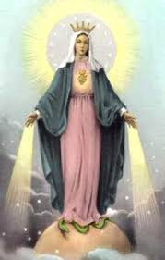

January 1 | — | Solemnity of Mary, Mother of God *
January 8 | — | Our Lady of Prompt Succor
February 2 | — | Presentation of the Lord
February 11 | — | Our Lady of Lourdes
March 25 | — | Annunciation
May 13 | — | Our Lady of Fatima
May 31 | — | Visitation
June 27  July 16 | —  — | Our Mother of Perpetual Help  Our Lady of Mount Carmel
August 15 | — | Assumption *
August 22 | — | Queenship of Mary
September 8 | — | Birth of Mary
September 12 | — | The Most Holy Name of Mary
September 15 | — | Our Lady of Sorrows
October 7 | — | Our Lady of the Rosary
November 21 | — | Presentation of the Blessed Virgin Mary
December 8 | — | Immaculate Conception *
December 12 | — | Our Lady of Guadalupe
* Holy day of Obligation

The Month of Mary is May.
The Month of the Rosary is October.
The Feast of the Immaculate Heart is the Saturday following
the Second Sunday after Pentecost.
The First Saturday of each Month is also dedicated to Marian Devotions.

